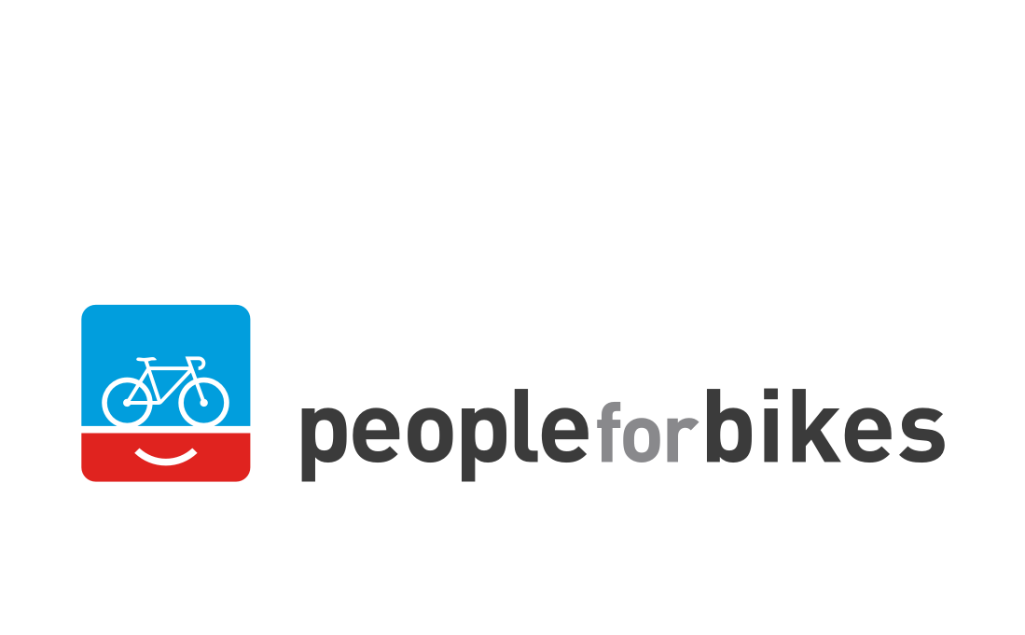

Media Contact:
Katie Flagg
Press Forward
kf@pressforwardpr.org
802.989.3465

2020 Bicycle Leadership Conference Rescheduled for Sept. 29 - Oct. 1

MONTEREY, CA (March 10, 2020) — The 2020 Bicycle Leadership Conference (BLC), originally slated for April 14 - 16, has been rescheduled for Sept. 29 - Oct. 1 in Monterey, California. The BLC is a PeopleForBikes event that has been produced in partnership with the Sea Otter Classic (SOC) for the last 11 years. SOC recently moved its 2020 dates to Oct. 1 - 4 in response to COVID-19 concerns.

PeopleForBikes plans to deliver an outstanding conference agenda on the new dates and is working to reconfirm the participation of the impressive speaker lineup originally announced for April. Keynotes include Birkenstock CEO David Kahan; Fast Company co-founder, best-selling author and entrepreneur Polly LaBarre; radio and podcast host Guy Raz; and StoryBrand’s Kristin Spiotto. All speakers and sessions will provide bike industry leaders with powerful ideas and best practices to help their companies thrive.

The new dates won’t change the setting (the beautiful Monterey Plaza Hotel and Spa on Monterey Bay) or the attendee list (that includes some of the most successful, influential leaders of the North American bike business). The agenda will encourage insightful discussions of industry trends, while leaving plenty of time for networking, recreating and celebrating.

The 2020 BLC will be the first edition of this important conference to be held after the July 2019 merger of the PeopleForBikes Coalition and Bicycle Product Suppliers Association. All of the newly united association’s key committees and subcommittees will meet in Monterey and report to the entire industry on their progress.

All registrations for the April BLC will automatically transfer to the September event. Registrants who are unable to attend in September should contact conference planner Meghan Carr (meghan@bicycleconference.com) to request a refund.

The Monterey Plaza Hotel and Spa set aside a block of rooms for fall BLC and SOC participants. The hotel will contact guests individually to move the reservations over. If you need assistance from the hotel, contact them directly at (800) 334-3999.

Most airlines are waiving change fees and some are offering full refunds on flights that need to be changed or cancelled because of concerns related to COVID-19. To participate in the full 2020 BLC, we recommend that you arrive in Monterey no later than 3 p.m. on Tuesday, Sept. 29 and depart no earlier than Friday morning, Oct. 2 (if you are unable to stay for the Sea Otter Classic).

About PeopleForBikes
PeopleForBikes is making better biking for everyone by uniting millions of individuals, thousands of businesses, and hundreds of communities. Because when people ride bikes, great things happen. Join us at PeopleForBikes.org.

