Front Fender on Canvas Neo Bicycles

Update: Fender Re-Attachment Parts Available January 2021

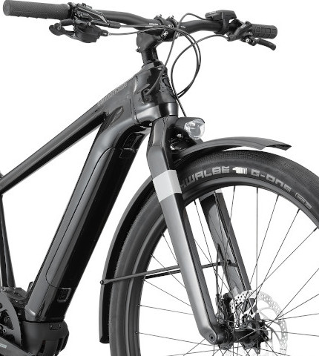
STOP RIDING UNTIL YOU HAVE
REMOVED THE FRONT FENDER

- Follow the removal instructions below

- Save the fender and fender struts

- After the fender is completely removed, you can keep riding your bicycle

- Contact your local authorized Cannondale dealer to re-install the fender with upgraded parts, at no charge.

At Cannondale, we know our riders demand the highest levels of performance, quality, and safety, and we hold ourselves and Cannondale products to that standard.

As we announced previously, following a few reports of issues with the hardware that attaches the front fender on some Cannondale Canvas Neo bicycles that caused the front fender to become detached from the bicycle and abruptly stop the front wheel, we elected to conduct a recall of the fender and fender attachment hardware in order to provide riders with an upgraded attachment system.

We have now completed testing and secured the government approvals required to conduct the recall.

Cannondale dealers and riders should remove the front fender and save the fender and fender struts for later re-attachment. It is easy to remove the front fender - instructions are included below and a step by step video is available on cannondale.com. Once the front fender is removed, you can keep riding your Canvas Neo without any front fender.

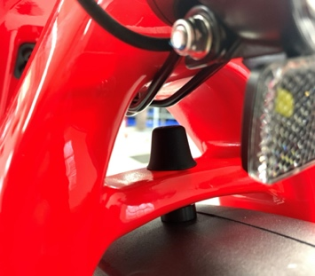
Upgraded attachment system
Please contact your local authorized Cannondale dealer or Cycling Sports Group to arrange for an authorized Cannondale dealer to re-install the fender with upgraded attachment hardware, at no charge. Consumers can remove the fender on their own, but it must be re-installed by an authorized Cannondale dealer.

We apologize for this inconvenience and thank you for your patience,
and for riding Cannondale.

Sincerely, The Cannondale Team

For more information: Visit https://www.cannondale.com/en-us/safety-and-recalls
View our Dealer Locator to find your local Cannondale shop; or contact our Customer Support Team
STOP RIDING, REMOVE THE FRONT FENDER
If you ignore this warning you can be seriously injured

Fender Removal Instructions

Step 1: Remove the front wheel

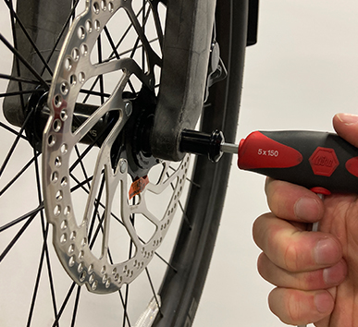
1A: If possible, put the bicycle into a work stand with the front wheel off the ground.
Or, hang the bike by the saddle or
lay the bike on its side on a soft surface.

1B: Insert a 5mm hex wrench into the side of the axle marked with “Max 11Nm”. Turn the wrench counter-clockwise until the axle is free to slide out and then slide it out.

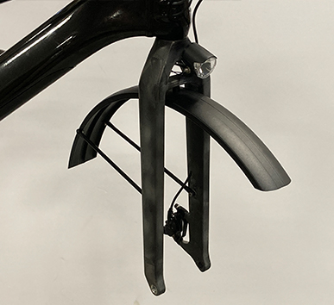
1C: Remove the front wheel from the fork. You may need to tap the top of the wheel with the palm of your hand to release the wheel from the fork.

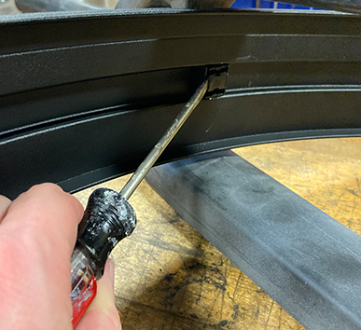
Step 2: Remove fender attachment to top of fork

2A: Remove the cover from the center fender bolt by prying with a small flathead screwdriver
(a new cover will be provided, so it is fine if the cover breaks)

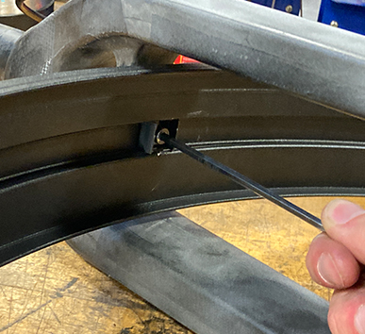
2B: Remove the center fender bolt with a 4mm hex wrench (you can discard this bolt – a new one will be provided)

Step 3: Remove the struts attaching the fender
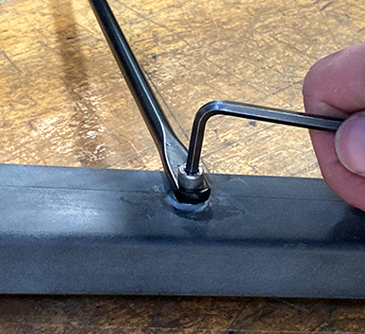
to the sides of the fork

Remove both fender bolts from the fender struts (you can discard the bolts – new ones will be provided). Save the fender and fender struts.

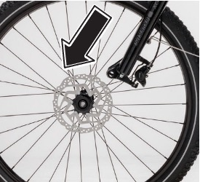
Step 4: Re-install the front wheel

4A: Re-install the wheel into the dropouts and align the hub with the fork dropouts.

NOTE: Ensure the brake disc slides in between the brake pads in the caliper as you insert the wheel between the dropouts.

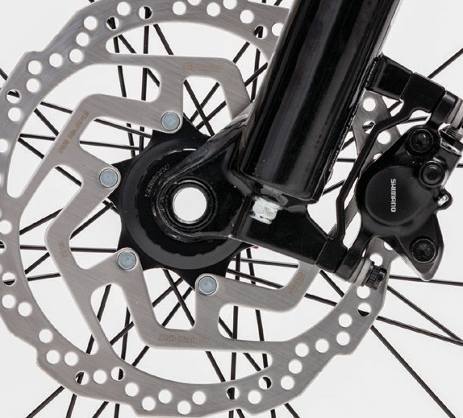
4B: Insert the thru-axle into the left side fork dropout and through the wheel hub.

4C: Insert a 5mm hex wrench into the side of the axle marked with “Max 11Nm” and turn the axle clockwise to screw the axle into the right-side dropout. Ensure the axle is very tight.

If you have any questions, please visit your local Cannondale retailer or call 1-800-BIKE-USA
ENSURE THE FRONT WHEEL HAS BEEN INSTALLED CORRECTLY.
If you ignore this warning you can be seriously injured

