Front Fender on Canvas NEO Bicycles

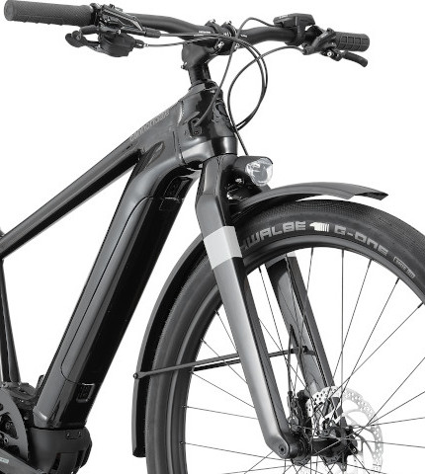
STOP RIDING UNTIL YOU HAVE
REMOVED THE FRONT FENDER

- Follow the removal instructions below

- Save the fender and fender struts

- After the fender is completely removed, you can keep riding your bicycle

- We are working with government agencies to conduct a recall of the fender and install an improved attachment system at no charge.

At Cannondale, we know our riders demand the highest levels of performance, quality, and safety, and we hold ourselves and Cannondale products to that standard.

We have received a few reports of issues with the hardware that attaches the front fender on some Cannondale Canvas NEO 1 and Canvas NEO 2 bicycles that caused the front fender to become detached from the bicycle and abruptly stop the front wheel, creating a fall and injury hazard.

We have elected to conduct a recall of the fender and fender attachment hardware
in order to provide riders with a more robust attachment system, and are working to finalize this improved attachment system and obtain required government approvals.

In the meantime, riders should remove the front fender from any bicycles and save the fender and fender struts for later re-attachment. If you have not already registered your bicycle for warranty and recalls, please register on cannondale.com. Once your bicycle has been registered, we will be able to contact you to complete the recall when we receive final government approvals.

It is easy to remove the front fender - instructions are included below.

Once the front fender is removed, you can keep riding your Canvas, without any front fender. We’ll be in touch as soon as possible to arrange for our professional staff to re-attach your front fender at no charge.

We apologize for this inconvenience and thank you for your patience, and for riding Cannondale.

STOP RIDING, REMOVE THE FRONT FENDER
If you ignore this warning you can be seriously injured

Fender Removal Instructions

Step 1: Remove the front wheel

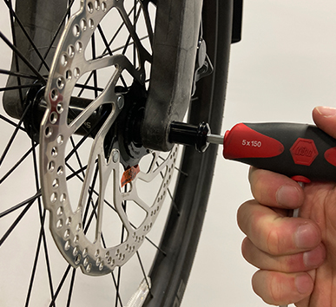
1A: If possible, put the bicycle into a work stand with the front wheel off the ground.
Or, hang the bike by the saddle or
lay the bike on its side on a soft surface.

1B: Insert a 5mm hex wrench into the side of the axle marked with “Max 11Nm”. Turn the wrench counter-clockwise until the axle is free to slide out and then slide it out.

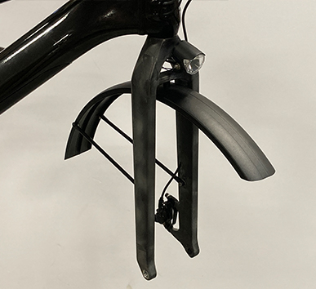
1C: Remove the front wheel from the fork. You may need to tap the top of the wheel with the palm of your hand to release the wheel from the fork.

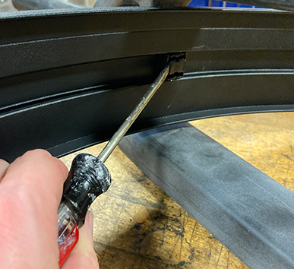
Step 2: Remove fender attachment to top of fork

2A: Remove the cover from the center fender bolt by prying with a small flathead screwdriver
(a new cover will be provided, so it is fine if the cover breaks)

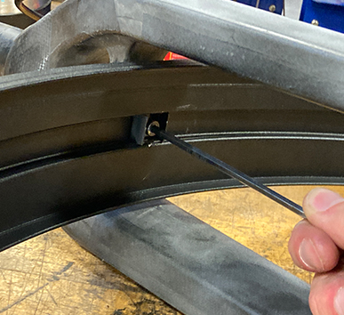
2B: Remove the center fender bolt with a 4mm hex wrench (you can discard this bolt – a new one will be provided)

Step 3: Remove the struts attaching the fender
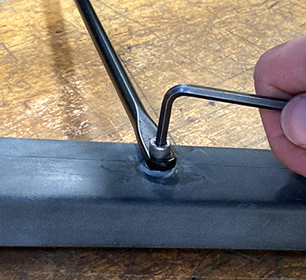
to the sides of the fork

Remove both fender bolts from the fender struts (you can discard the bolts – new ones will be provided). Save the fender and fender struts.

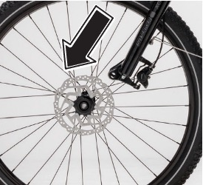
Step 4: Re-install the front wheel

4A: Re-install the wheel into the dropouts and align the hub with the fork dropouts.

NOTE: Ensure the brake disc slides in between the brake pads in the caliper as you insert the wheel between the dropouts.

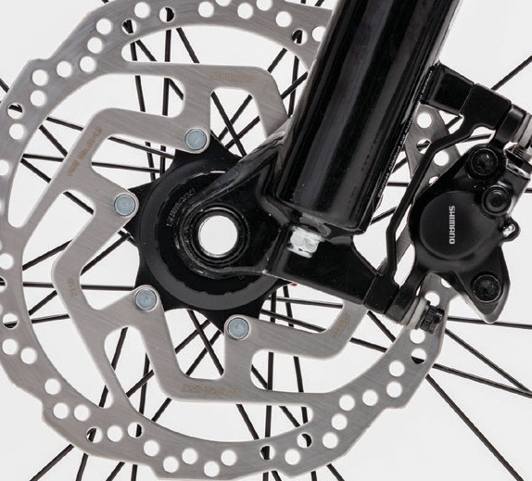
4B: Insert the thru-axle into the left side fork dropout and through the wheel hub.

4C: Insert a 5mm hex wrench into the side of the axle marked with “Max 11Nm” and turn the axle clockwise to screw the axle into the right-side dropout. Ensure the axle is very tight.

If you have any questions, please visit your local Cannondale retailer or call 1-800-BIKE-USA
ENSURE THE FRONT WHEEL HAS BEEN INSTALLED CORRECTLY.
If you ignore this warning you can be seriously injured

